**F-STWR2.0.2（Windows） Operation Manual**

**Rembem to set the installation path to the environment variable PATH**

**Normal operation steps：**

1. **Input Data file：*.csv (format)**

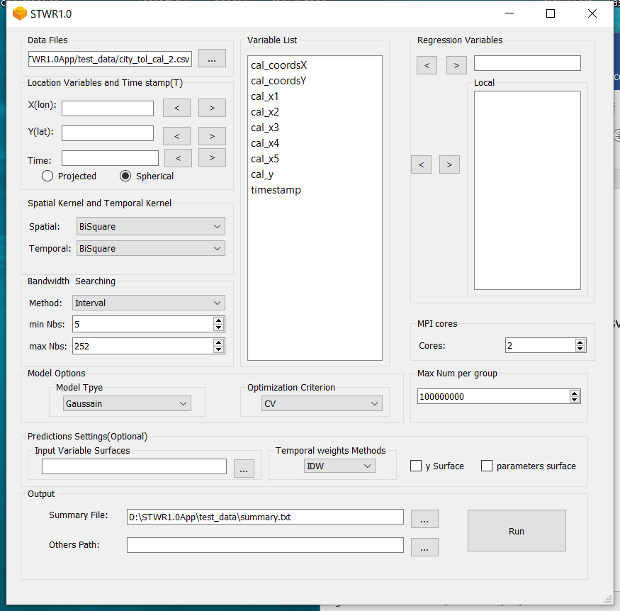

1. **Set the coordinates, dependent, independent and time variables**

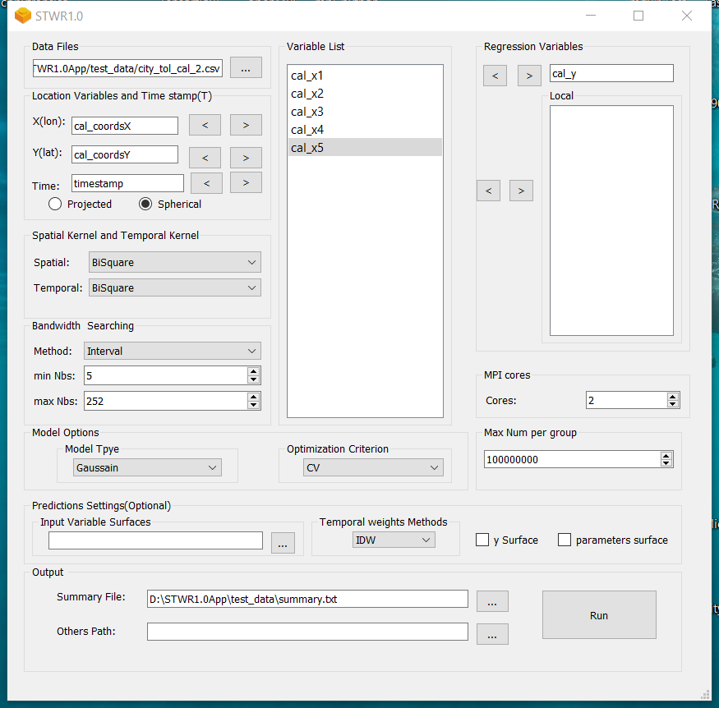

1. **Set whether to predict of just to fit model. If you need to predict, the “Input Variable Surfaces” field should be specified to a folder path, in which the file names of the arguments in all Variable Lists. For example, set a folder path as below**

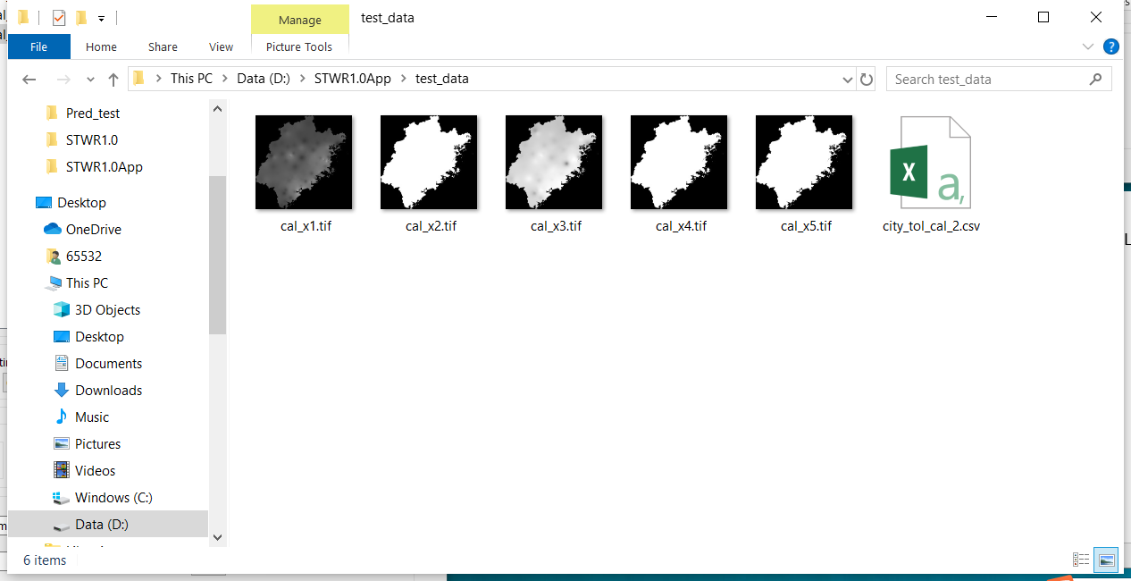

1. **Set the parameter number of “MPI cores” according to your own computer core number.**
2. **If your computer memory is not enough, set the field “MaxNum per group” with smaller number like 2000000.**
3. **Check whether to predict the parameters surface.**
4. **Set the output path.**
5. **Push the Run button and wait for the result.**